**Question/Answer Booklet**

**Name:**

**PHYSICAL EDUCATION STUDIES YEAR 11 ATAR**

**Semester 1 Exam**

**Time allowed for this paper**

Reading time before commencing work: 0 minutes

Working time for paper: 2 Hours

***To be provided by the candidate***

Standard items: pens (blue and black), pencils, eraser, correction fluid, ruler, highlighter

**Important note to candidates**

No other items may be taken into the examination room. It is **your** responsibility to ensure that you do not have any unauthorised notes or other items of a non-personal nature in the examination room. If you have any unauthorised material with you, hand it to the supervisor **before** reading any further.

**Structure of paper:**

|  |  |  |  |
| --- | --- | --- | --- |
| Section | Number of questions available | Number of questions to be attempted | Marks available |
| **Section One:**  Multiple-Choice | 20 | 20 | 20 |
| **Section Two:**  Short Answer | 15 | 15 | 60 |
| **Section Three:**  Extended Answer | 2 | 2 | 30 |
|  |  |  | **110** |

Answer the twenty **(20)** Multiple-Choice questions on the separate Multiple-Choice answer sheet provided.

**Multiple Choice (20 marks)**

1. Which of the following is not a characteristic of capillaries?

(a) Exchange carbon dioxide and oxygen.

(b) Have thin walls.

(c) Are microscopic.

(d) Have strong elastic walls.

1. Which of the following is **not** a characteristic of arteries?

(a) Carries blood away from the heart.

(b) Thick elastic walls permit continuous blood flow.

(c) Blood flow is created by the beating of the heart.

(d) Blood flow is created by the contraction of muscles.

1. The origin point for the hamstring muscle group is located on the:

(a) Pelvis.

(b) Femur.

(c) Tibia.

(d) Fibula.

1. Identify the joint movement performed by a swimmer’s shoulders during a backstroke race:

(a) Adduction.

(b) Flexion.

(c) Extension.

(d) Circumduction.

1. In the action of kicking and making contact with a football, the leg and the agonist muscle group is the .
2. Extends, Gluteals.
3. Flexes, Quadriceps.
4. Flexes, Hamstrings.
5. Extends, Quadriceps.
6. Skeletal muscle tissue has many characteristics, which aid in the production of movement. In gymnastics, the ability for a muscle to stretch when a force is applied is critical to successfully performing choreographed routines. This is referred to as the muscles:

(a) Excitability.

(b) Contractibility.

(c) Extendibility.

(d) Elasticity.

1. Which of the following muscle groups are **not** antagonistic pairs?
2. Biceps, Triceps.
3. Trapezius, Deltoids.
4. Tibialis anterior, Gastrocnemius.
5. Gastrocnemius, Soleus.
6. A muscle directly involved in causing a segment to move is called the

(a) agonist

(b) antagonist

(c) stabiliser

(d) controller

1. Which one of the following statements is **true** of the bloods pathway?
2. Blood enters the Right Ventricle, then flows to the Right Atrium, before traveling into the Pulmonary Vein and returns to the heart via the Pulmonary Artery.
3. Blood enters the Left Atrium, then flows to the Left Ventricle, before traveling into the Pulmonary Artery and returns to the heart via the Pulmonary Vein.
4. Blood enters the Right Atrium, then flows to the Right Ventricle, before traveling into the Pulmonary Artery and returns to the heart via the Pulmonary Vein.

(d) Blood enters the Right Atrium, then flows to the Right Ventricle, before traveling into the Pulmonary Vein and returns to the heart via the Pulmonary Artery.

1. In water polo, goal keepers defend by elevating their arms above their head. Which superficial muscle of the back contracts to elevate the scapula and produce the defensive position shown in the image below?

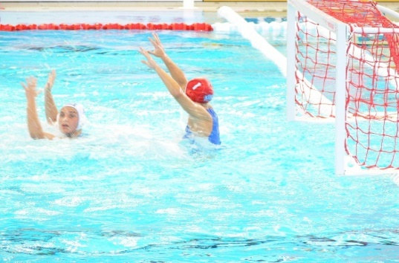

(a) Trapezius

(b) Triceps

(c) Deltoid

(d) Latissimus Dorsi

1. The mechanism responsible for increased blood flow to the working muscles is:

(a) vasoconstriction

(b) vasodilation

(c) the muscle pump.

(d) reduced cardiac output.

1. Which of the following muscles does not have its insertion point located on the humerus?
2. Deltoid.
3. Latissimus dorsi.
4. Biceps.
5. Pectoralis major.
6. An athlete underwent an extensive period of anaerobic training. During this period, they ran varying distances no longer than 400m and typically at a very high intensity. Which of the following chronic adaptations would be least likely to occur?

(a) an increase in the number and size of mitochondria

(b) an increase in glycolytic enzymes

(c) an increase in ATP-PC stores

(d) an increased tolerance of lactic acid

1. The following table represents a training day for a 3000m runner.

|  |  |  |  |  |
| --- | --- | --- | --- | --- |
| **Set** | **Reps** | **Distance** | **Time to complete repetition** | **Rest (between reps)** |
| 1 | 6 | 400m | 75 seconds | 90 seconds; jog/walk |
| 2 | 6 | 600m | 120 seconds | 150 seconds; jog/walk |

What type of training method is the athlete using?

(a) continuous

(b) fartlek

(c) interval

(d) plyometrics

15. The following table represents a phase of a resistance training program for an elite rugby player.

|  |  |  |  |
| --- | --- | --- | --- |
| **Weight** | **Sets** | **Reps** | **Rest (between sets)** |
| 90% 1RM | 3 | 4-6 | 3 minutes |

Which fitness component does this phase of the training program specifically target?

(a) aerobic power

(b) muscular endurance

(c) muscular strength

(d) muscular power

1. During energy system interplay:

(a) all three energy systems contribute to ATP production however, at any stage, one of them is the main contributor.

(b) all three energy systems supply energy continuously.

(c) the two anaerobic energy systems have been exhausted and most energy is derived from the aerobic energy system.

(d) all three energy systems work sequentially.

17. Fartlek training:

(a) include predetermined work:rest ratios

(b) should be overloaded by completing an increased distance in a slower time

(c) must include regular rest periods to restore phosphate creatine levels

(d) combines continuous activity with short bursts of intense work at irregular intervals

18. The arteriovenous oxygen (a-vO2) difference:

(a) plateau's when VO2 max is reached

(b) decreases in response to increased exercise loads

(c) increases in response to increased exercise loads

(d) is only fuelled by the aerobic energy system

19. In preparation for major sporting events, coaches will often implement variety into their training programs in order to try and mitigate reduced motivation in athletes. Which of the following training principles need to be closely considered when introducing variety?

(a) Progressive overload

(b) Intensity

(c) Duration

(d) Specificity

20. The muscle responsible for opposing movements to the prime mover muscle are called:

(a) agonist

(b) antagonist

(c) synergist

(d) reciprocal inhibition

**Short Answer (60 marks)**

This section has **Fifteen (15)** questions. Answer **all** questions. Write your answers in the spaces provided in this Question/Answer Booklet. Wherever possible, confine your answers to the line spaces provided. Use a blue or black pen (**not** pencil) for this section.

**Question 21 (5 marks)**

Identify the anatomical features within the right lung in the diagram below.

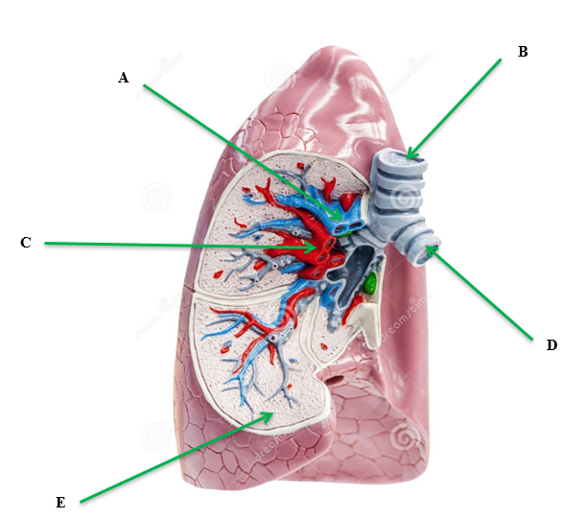

|  |
| --- |
|  |
|  |
|  |
|  |
| E. |

**Question 22 (4 marks)**

The body consists of three types of blood vessels: arteries, veins and capillaries. Compare and contrast **two (2)** characteristics of veins and arteries.

**Question 23 (6 marks)**

The following question relates to the image below of the footballer performing a defensive slide tackle.

.



1. Identify the articulating bones of the hip joint. (2 marks)

1. Identify the movement of the defending players’ left knee and ankle which is attempting to intercept the ball in the tackle. (2 marks)

1. Identify the agonist muscles responsible for the movement in the defending players’ left knee and ankle. (2 marks)

**Question 24 (6 marks)**

Identify the **muscles** A through to F on the diagram below. Answer in the space provided below.

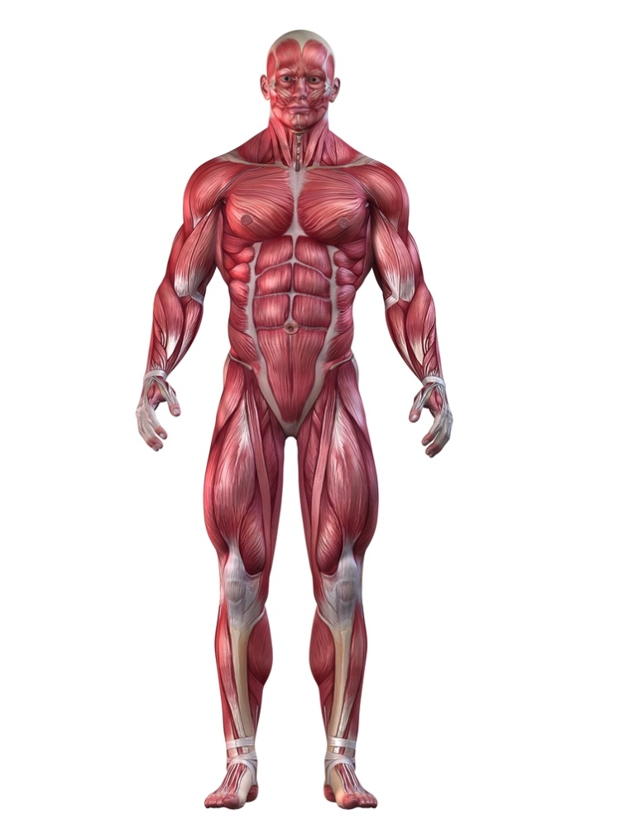

**A**

**B**

**C**

**D**

**E**

**F**

|  |  |  |
| --- | --- | --- |
| **A.** | **B.** | **C.** |
| **D.** | **E.** | **F.** |

**Question 25 (6 marks)**

An athlete performs eight repetitions of 200 m as part of a training session. Each repetition is performed in 30 sec and is followed by 90 sec of active recovery and 3 minutes of rest between each repetition.

(a) What is the name of the training method described above?

(1 mark)

(b) What is the major energy system being trained?

(1 mark)

(c) What is the major energy source fuelling each repeat sprint

(1 mark)

(d) Describe the principle of progressive overload and identify two (2) ways it could be applied to the training program outlined above.

(3 marks)

**Question 26 (4 marks)**

Using examples, explain **two (2)** types of balance a gymnast may display during a floor routine.

___

**Question 27 (8 marks)**

The following question relates to the image below of a triple jumper.

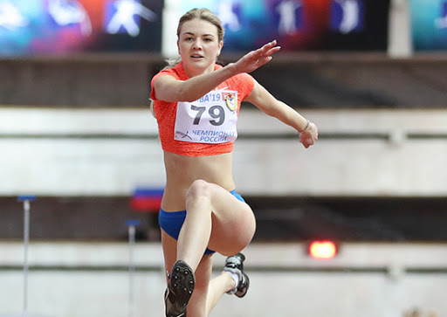

(a) Identify the three (3) articulating bones that make up the elbow joint. (3 marks)

(b) Identify the movement taking place at the athlete’s left elbow joint. (1 mark)

(c) Identify the agonist and antagonist muscles responsible for the movement in (b).

(2 marks)

(d) Identify the articulating bones that make up the hip joint.

(2 marks)

**Question 28 (6 marks)**

The following table represents a weights program for an athlete to improve their muscular strength.

Exercise Sets Repetitions Resistance

|  |  |  |  |
| --- | --- | --- | --- |
| Exercise | Sets | Repetitions | Resistance |
| Squats | 3 | 6 | 8RM |
| Bench press | 3 | 2 | 4RM |
| Dead lifts | 3 | 15 | 40%RM |
| Military press | 3 | 4 | 4RM |
| Lat pull downs | 4 | 4 | 4RM |
| Leg extension | 4 | 4 | 50%RM |

(a) To achieve improvements in muscular strength, how many times per week would the athlete need to undertake the above weights training schedule?

(1 mark)

(b) In the table, what does 4RM stand for/represent?

(1 mark)

(c) Do any prescriptions of sets, repetitions and resistance seem inappropriate to the stated goal of muscular strength improvement? Justify your answer.

(3 marks)

(d) In a three-month program consisting of the exercises from the table, indicate when overload should be applied.

(1 mark)

**Question 29 (5 marks)**

The following graph shows the varying contributions of fats and carbohydrates during submaximal exercise.

(a) At what point does the athlete make the switch to fats as the dominant fuel supply?

(1 mark)

(b) Explain the impact this is likely to have on their performance.

(2 marks)

(c) Outline two (2) nutritional strategies the athlete could use to delay the switching to

fats as the predominant fuel source.

(2 marks)

**Question 30 (10 marks)**

The following graph shows the relative contributions of the different energy systems during a four (4) minute maximal intensity exercise bout.

(a) At what point does the anaerobic glycolysis system become the dominant energy

provider?

(1 mark)

(b) Explain why there is a delay before the aerobic energy system becomes the

dominant provider. How does the body cater for this?

(3 marks)

(c) At the 60sec mark, identify the fuel providing most energy for ATP production.

(1 mark)

(d) Discuss the concept of energy system interplay as it relates to the event in the graph

above.

(5 marks)

**Extended Answer (30 marks)**

This section contains two (2) questions. **You must answer two (2) of these questions.** Write your answer in the spaces provided.

Spare pages are included at the end of this booklet. They can be used for planning your responses and/or additional space if required to continue an answer.

* Planning: if you use the spare pages for planning, indicate this clearly at the top of the page.
* Continuing an answer: If you need to use the space to continue an answer, indicate in the original space where the answer is continued, i.e. give the page number. Fill in the number of the question that you are continuing to answer at the top of the page.

**Question 31**

(a) From the point of inhalation, describe the mechanics of breathing, including pressure change and flow of oxygen through the cardiorespiratory system to supply oxygen to the working muscle/s. (10 marks)

(b) Draw and label a diagram that shows blood flow through the heart.

(5 marks)

**Question 32 (15 marks)**

Two athletes set themselves the goal of competing in the London Marathon in June 2020. Athlete A is considered a trained athlete, having competed in marathons previously and regularly trains. Athlete B is considered untrained, having never run a marathon before and currently lives a relatively sedentary lifestyle.

(a) Compare the maximal cardiac output, resting heart rate and maximal stroke

volumes of Athlete A and B prior to starting their new training regimes. Furthermore

discuss two methods of training Athlete B could use to improve these dimensions.

(7 marks)

(b) Identify and outline four (4) long term respiratory adaptations Athlete B is likely to

receive as a result of a six month aerobic training program.

(8 marks)